
ADVANCED DATA STRUCTURES AND ALGORITHM

(MTITC101)

Submitted By: Aniket Sonker
Roll no: 2026PIT4227
Branch: Information Technology
Practical-7
Aim: To implement an Arbitrary Tree and a B-Tree with configurable minimum degree $t$ in C++, perform essential tree operations (traversals, searching, structural metrics, and node splitting), and analyze their structural behavior for various configurations and large input sizes.

Task1: 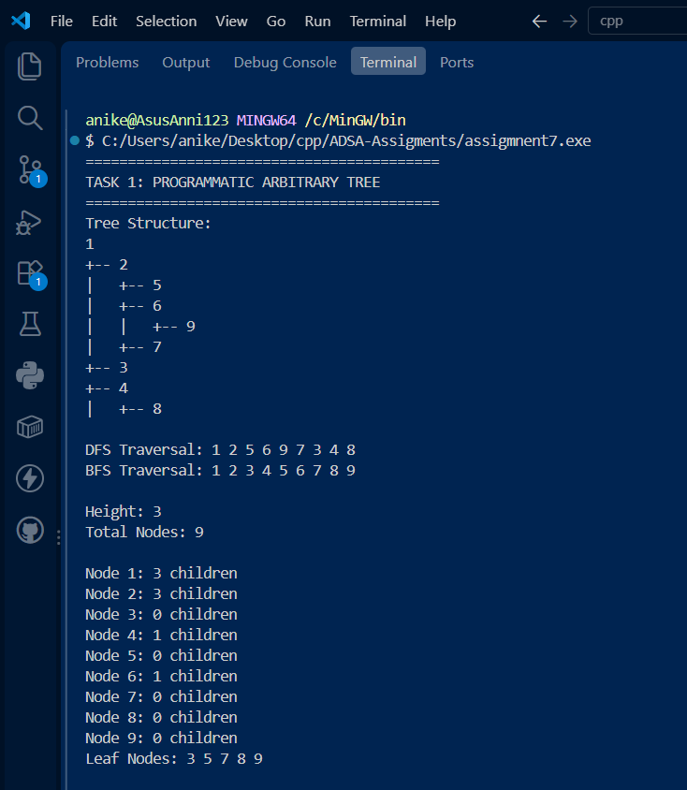

Task2: 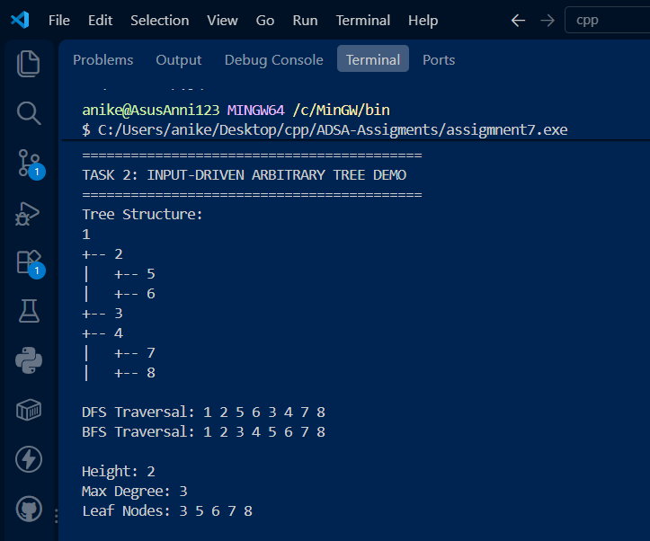

Task3: 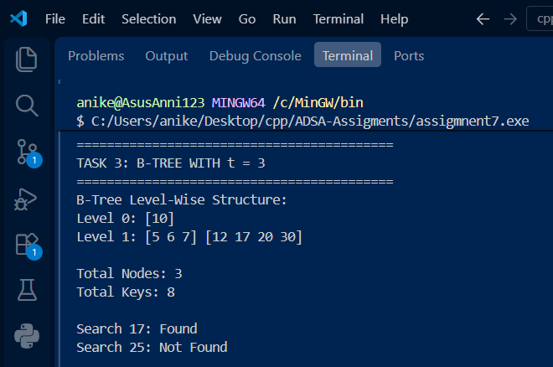

Task4:
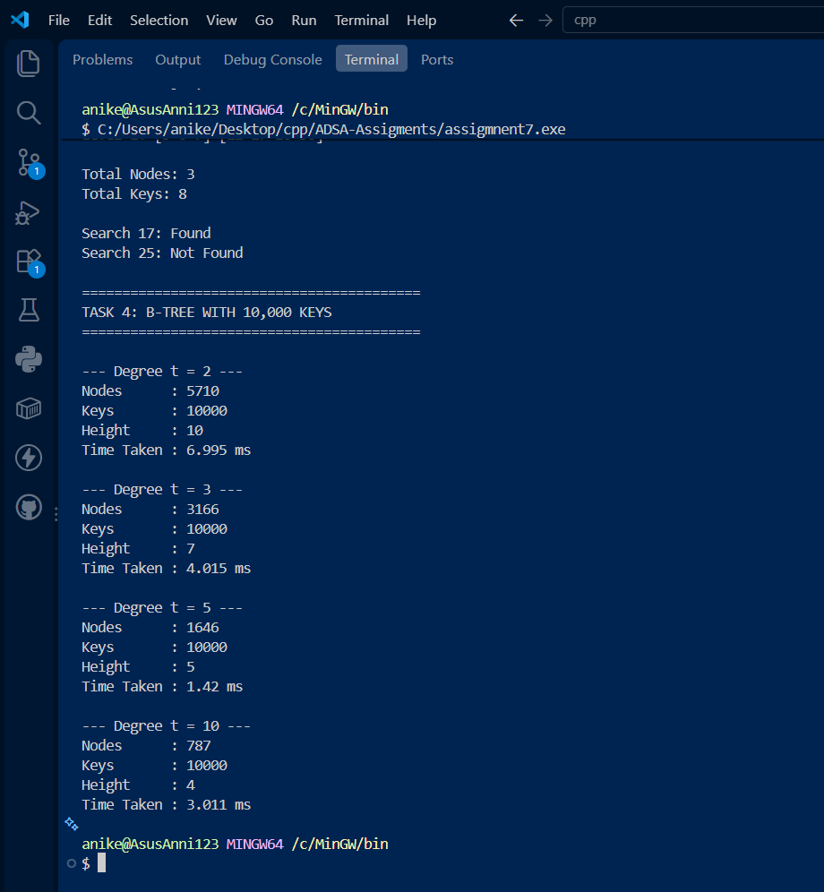

Observation & Result
- Arbitrary Tree Traversal & Metrics:
  - DFS vs. BFS: DFS processes deepest descendants first via recursion, while BFS scans level-by-level using a FIFO queue.
  - Structural Heights & Degrees: The height function accurately measures the longest root-to-leaf path length. Nodes without children are identified as leaf nodes (children.empty()).
- B-Tree Behavior with Varying Degrees ($t$):
  - Degree Bounds: Every non-root node stores between $t-1$ and $2t-1$ keys. Node splitting preserves balanced height across insertions.
  - Performance Scaling ($10,000$ Keys):
    - Higher values of $t$ allow nodes to hold more keys per block, reducing total node count ($6,734→721$) and decreasing tree height ($13→4$).
    - Flatter tree heights significantly optimize disk I/O operations and lookup times.

